Integrated Lane Departure and Drowsiness Detection for Mitigating False Alarms

Mansi Dhamne , Yash Desai , Vivek Raheja, Sudhir Dhage
dept. of Computer Engineering
Sardar Patel Institute of Technology
Mumbai, India

Abstract—Road accidents in India remain a critical issue, with over 4.6 lakh accidents reported in 2022 according to the Ministry of Road Transport and Highways, resulting in 1.68 lakh deaths and 4.43 lakh injuries. These numbers highlight the need for effective measures to mitigate accidents caused by speeding, reckless driving, and driver fatigue. To address this, we propose an integrated system that combines Lane Departure Detection and Driver Fatigue Detection to accurately detect driver drowsiness and reduce false alarm rates. Leveraging OpenCV for real-time video processing, the system monitors lane markings and vehicle position to detect lane departure, while also detecting driver fatigue through facial recognition and eye and mouth aspect ratios using Dlib. On detection, alerts and SOS notifications to dependents and healthcare facilities will be triggered ensuring timely assistance, improving road safety.
Index Terms—Computer Vision, OpenCV, Dlib, False Alarm Rate, Lane Departure, Drowsiness Detection

- Introduction
Each year, drowsy driving accounts for about 328,000 crashes, 109,000 injuries and about 6,400 fatalities per year, according to the latest study [1]. Drowsy and tired driving is dangerous because many people are unaware of how tired they are until they are behind the wheel of a car, potentially putting themselves and others at risk. This paper presents an advanced integrated solution combining Lane Departure Detection (LDD) and Driver Fatigue Detection (DFD) systems to trigger alarms accurately. The goal is to tackle these prevalent issues while substantially reducing the occurrence of false alarms, which are common in traditional systems.
This innovative system leverages sophisticated facial recog- nition technology to continuously monitor indicators of driver fatigue, such as prolonged eye closure and frequent yawning. Concurrently, it analyzes vehicle dynamics to identify unin- tended lane deviations. The integration of these models allows for a more accurate correlation between the driver’s state of alertness and potential lane departures, thereby enhancing the system’s precision in issuing warnings.
One of the critical challenges addressed in this research is the minimization of false alarms. To achieve this, a robust multi-layered verification process is employed. This process meticulously cross-references potential triggers, such as con- sistent lane departure, sustained yawning, and eye closure, ensuring that alerts are triggered only when there is a high likelihood of genuine driver impairment. This significantly reduces unnecessary distractions and improves the overall reliability of the system. Furthermore, the system is equipped with an automatic SOS feature, designed to activate in critical situations. When a severe level of drowsiness or a dangerous lane departure is detected after multiple alarms, this feature automatically sends the driver’s exact geolocation to prede- termined contacts via a public messaging platform, using a geolocation API. This functionality ensures that emergency assistance can be quickly mobilized, potentially averting acci- dents.
The aim of this paper is to advance road safety by creating a highly dependable driver assistance system. This system not only detects drowsiness and lane departures with remarkable accuracy but also minimizes false alarms, thereby prioritizing the safety of drivers, passengers, and other road users through timely and trustworthy alerts, complemented by an automated emergency response mechanism.
The paper is structured as follows. Section II discusses previous works related to various DFD and LD detection methodologies. Section III covers our proposed methodology. Section IV illustrates the experimental results. At last, the research is concluded in Section V.
- Literature Survey
- Lane Departure
Lane detection necessary for lane keeping and lane depar- ture control systems, minimising the chances of collision. Mul- tiple approaches have been worked on: deep neural network

for lane detection in 3D space,waveforms and CNNs for de- tecting lane markings for safe AD. The paper further mentions the challenges in this domain including “Complexity of AD Systems”, “Integration/Fusion of Sensory Data for Dynamic Decision Making”, “Big Data and Real-Time Processing”, “Fairness, Accountability, and Transparency in DL for AD”. [1]
Ankita Kamble et al. [3] presented an efficient lane depar- ture warning system using the canny edge detection algorithm for lane detection and Hough transform for lane correctness. The Euclidean distance is combined with the PLSF algorithm. This system was effective for on straight and curve road at an highest accuracy of 92.28
Salna Joy et al. [4] employed a real-time video feed, analyzing each frame. Noise is removed using a Gaussian filter, followed by Canny edge detection and masking of image to focus on ROI The Hough Transform locates lines which are overlaid onto the original image, providing a visual representation of the identified lane boundaries. The system effectively extracts lane information from real-time video, guiding the autonomous vehicle within its designated lane.
Domagoj Sˇpoljar et al. [5] proposed a lane departure (LD) algorithm based on feature-based methods and parabolic line modeling. The algorithm involves seven image processing steps - RGB, HLS, LAB colour spaces and Sobel Operator to detect edges in the images. The system struggles with partially visible lines. Suggestion of incorporating a neural network to improve speed and accuracy in such scenarios.
Zhonglei Gao et al. [6] proposed a method that defines a region of interest, binarizes it, extracts gradients, performs contour detection, and leverages a scoring system to identify lane lines. By combining lane contours with gradients, it gen- erates points for least-squares fitting, achieving high detection accuracy of 96
Building on this foundation, Wang et al. [8] introduced a learning-based approach for lane departure warning systems with a personalized driver model. Their approach involved establishing a personalized driver model for lane departure and lane-keeping behavior using a combination of the Gaussian mixture model and the hidden Markov model. By developing an online model-based prediction algorithm, they successfully predicted upcoming vehicle trajectories and identified unin- tended lane-departure behaviors (LDB) or driver corrections (DCB). This approach aimed to reduce false alarm rates and enhance driver safety.
Proposed in [2], it states that lane detection is necessary for lane keeping and lane departure control systems, minimis- ing the chances of collision. Multiple approaches have been worked on like deep neural network for lane detection in 3D space, waveforms and CNNs for detecting lane markings for safe AD and energy-friendly lane detection and classification strategy is proposed using stereo vision and CNN for lateral positioning of ego-car and issuing forward collision warning for safe AD
- Driver Drowsiness
  - PERCLOS (Percentage of Eyelid Closure Over the Pupil Over Time) computation using images captured from the front camera of the smartphone.
  - Voice-based verification where the system asks the driver to say their full name if PERCLOS exceeds a preset threshold.
  - Touch response verification where the driver is asked to touch the screen of the smartphone within 10 seconds if they are found to be fatigued by the previous stages.
  - Logging of PERCLOS values for each minute along with GPS coordinates to document instances of drowsiness.
  - Sound alarm warning when the driver is identified as drowsy, and a repeating loud alarm via the car’s speakers if the driver is drowsy five consecutive times.
Drowsiness Detection [1] is related to drivers and especially for level 1 to level 3 autonomous vehicles. It is one of the key contributors for safety applications as it can automatically take necessary action once drowsy state is detected. The most favourable approach was a multi-granularity based deep frame- work by intelligent usage of CNN and LSTM drowsiness detection in videos. Shruti Mohanty et al. [7] proposes a drowsy driver detection system using Python and Dlib model. Dlib’s shape detector is used to map the coordinates of the facial landmarks of the input video and drowsiness detected by monitoring aspect ratios of eyes and mouth. This system gave a maximum recognition accuracy of 96.71
Vipul Agarwal et al. [9] proposes using the Haar Training Algorithm - converting the image to grayscale and finding the eyes using their position and shape. It analysed the eye shape (open or closed) using Euclidian distance and 6 landmark points. This approach relies on image processing techniques to detect eye features and assess drowsiness based on their appearance.
Aneesa Al Redhaei et al [10] proposes a system that uses facial landmarks and face mesh detectors to locate the regions of interest where mouth aspect ratio, eye aspect ratio, and head pose features are extracted and fed to three different classifiers: random forest, sequential neural network, and linear support vector machine classifiers. This system could successfully detect and alarm drowsy drivers with an accuracy up to 99
These approaches aim to enhance accuracy and reliability in detecting driver drowsiness, especially in varying environ- mental conditions and lighting situations
- Methodology
The entire project is divided into three sections: Drive Fatigue Detection System, Lane Departure Detection System and finally integration of both the systems.
- Driver Fatigue Detection
Driver Fatigue is detected using OpenCV and Python. The Dlib library is used to detect and localize facial landmarks using Dlib’s pre-trained facial landmark detector. It consists of a shape predictor model [2] trained on the i-Bug 300-W dataset, that localizes 68 landmark points respectively within

a face image. The camera is placed on the dashboard of the car with the help of a mobile stand. Frame width is taken to be 1024x576 in accordance with modern day smartphones.

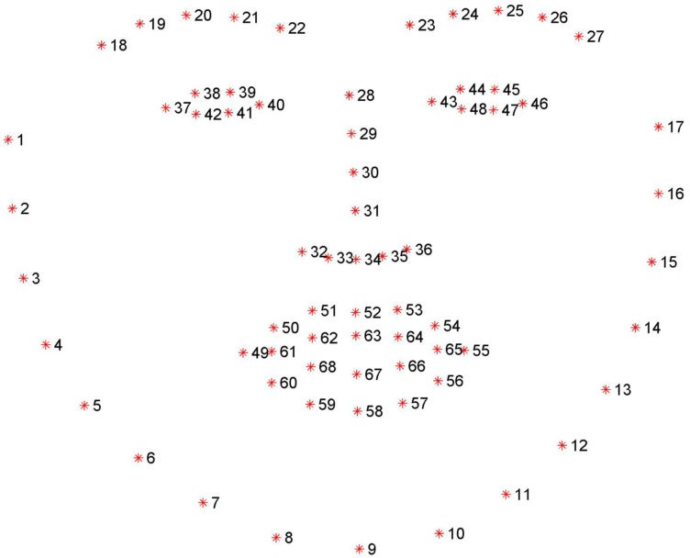

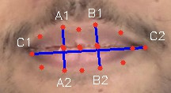
  - Mapped landmarks when driver is not yawning

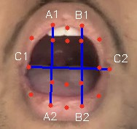
  - Mapped landmarks when driver is yawning

Fig. 1: 68 landmarks mapped on the detected face.

In each frame of the real time video, the system detects faces using the Dlib frontal face detector. If a face is detected, facial landmarks: (left eye, right eye and mouth coordinates) are extracted to identify the regions of the eyes and mouth. The eyes are then analyzed for Eye Aspect Ratio (EAR), and the mouth for Mouth Aspect Ratio (MAR).
The Eye Aspect Ratio (EAR) is defined as:

||A₁ − A₂|| + ||B₁ − B₂||
Fig. 3: Calculating MAR
EAR and MAR are calculated for each frame in the real time video and their values are checked against the experimentally derived thresholds. A yawning counter is set which increases by 1 every time the driver yawns. If the driver yawns for more than 20 times (experimentally set up), an alarm is run informing the driver to take a break. Similarly an blink counter is set which increases if the EAR comes within the threshold. If this counter value increases above 10, a drowsy alarm is triggered which corrects the driver’s unnatural behavior.

EAR =
2 × ||C₁ − C₂||
(1)

where:
    - A₁, A₂, B₁, B₂, C₁, C₂ are the 2D coordinates of the eye landmarks.
    - ||A₁ − A₂|| denotes the Euclidean distance between the points A₁ and A₂.
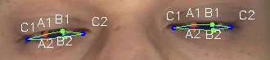
      - Mapped landmarks when driver’s eyes are closed
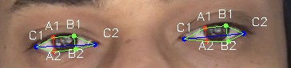
      - Mapped landmarks when driver’s eyes are open
Fig. 2: Calculating EAR

The Mouth Aspect Ratio (MAR) is defined as:

||A₁ − A₂|| + ||B₁ − B₂||

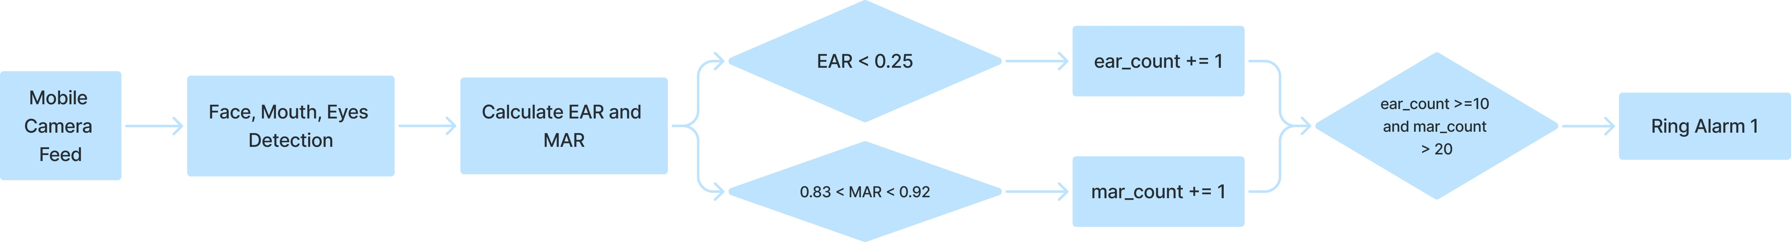
Fig. 4: Block Diagram of Driver Fatigue Detection

- Lane Departure Detection
A web-camera of frame dimensions 1280x720 is placed on the windscreen of the car to capture video for lane departure.
- Calibration: The camera calibration function uses multi- ple chess board images to correct lens distortion. Using inbuilt OpenCV functions the corners of the chessboard patterns are detected and on positive detection of the corners the 3D and 2D array values of images are stored respectively. OpenCV’s calibrateCamera function estimates the camera matrix and distortion coefficients which are later saved into a dictionary prepared to load into a pickle file.
- Frame Preprocessing: The image is first converted from BGR to HLS (Hue, Lightness, Saturation) color space from where the S channel is extracted. A binary mask is created based on a threshold applied to the S channel, highlighting areas with a specific saturation level.
  - Sobel operator is a convolution operation used to cal-

where:
MAR =
2 × ||C₁
(2)
— C₂||
culate the gradient of the image intensity in both the x and y directions. We calculated the gradient only in the x-direction to decrease the computation time and focus only on the vertical features of the frame. The

  - A₁, A₂, B₁, B₂, C₁, C₂ are the 2D coordinates of the mouth landmarks.
  - ||A₁ − A₂|| denotes the Euclidean distance between the points A₁ and A₂.
resulting gradient approximations were combined to find the absolute gradient magnitude at each point and thus highlighting regions of high spatial frequency that corre- spond to edges. The gradient magnitude is scaled to 8-bit

size. A binary threshold is applied to further highlight the detected lane markings.
  - The gradient direction is computed, and a binary mask is created based on the direction threshold to detect edges that are oriented within a specific angle range.
  - Both binary images resulting from Sobel Edge Detection and Direction and Color Thresholding are efficiently combined to finally produced a processed frame which highlights lane lines.
- Warping: The image is warped to be converted to Bird’s Eye View with the help of a perspective matrix transformation. By warping the image the Lane Detection Algorithm easily identifies the already converging original (feed) lane lines to the parallel lines trying to match the destination (ideal) points.
- Lane Detection Algorithm: This is divided into two subparts - Full Search Algorithm and Sliding Window Search Algorithm
  - Full Search: It is used to perform search for lane lines in a warped binary image assuming no previous lane lines are known. The peaks in each half of the histogram of the converging lane correspond to the start and end points of both the lanes. All identified nonzero pixels are marked as potential lane line pixels.
  - Window Search: It updates the position of lane lines in each frame of a video based on previous lane positions. By fitting a polynomial to the detected lane pixels, it can accurately track curved lanes.The binary image after full search is divided into horizontal layers where each layer act as a margin to identify lane lines with non-zero pixels. The function returns the new fitting polynomials for the current frame which are used for the next frames to continue tracking the lanes.
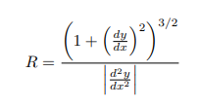
- Road Curvature: To accurately calculate the curvature, the left and right lanes are converted from pixels to meters using real-world space using scaling factors. Average of both the curvatures is calculated using a second-degree curve fitting polynomial.

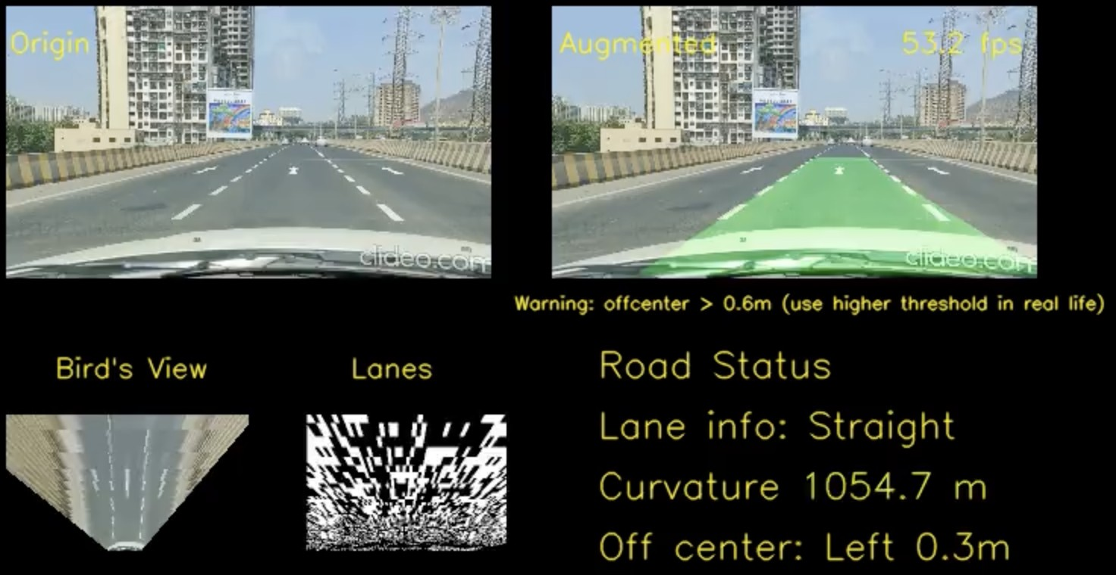
Fig. 5: Real-time lane detection with road curvature and off- center warning display

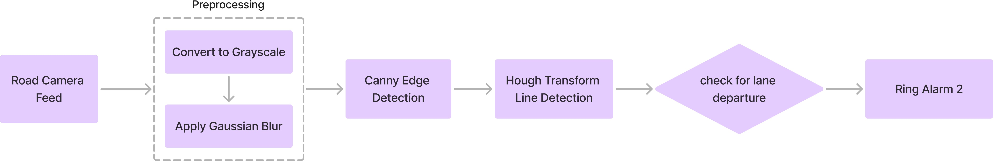

Fig. 6: Block diagram of Lane Departure Detection

- Integration
Both the Driver Drowsiness and Lane Departure systems are integrated with the following multi-layered validation approach to enhance safety and reduce false alarms:
- If 10 consecutive drowsiness frames are detected, an alarm is triggered to alert and wake the driver.
- If 20 consecutive yawning frames are detected, the system prompts the driver to take a break, suggesting a coffee stop.
- If lane departure and drowsiness are detected simulta- neously for 10 consecutive frames, an SOS signal is registered, and a louder alarm is triggered.
- Upon the accumulation of 5 SOS signals, a RED ALERT is issued. The system automatically extracts the driver’s live location using a geolocation API and sends it to their emergency contacts and nearby government healthcare services.
This multi-tiered validation system is designed to minimize

(3)
false alarms while effectively identifying and responding to hazardous driving conditions, ensuring driver safety in a more reliable manner.

where R is the radius of curvature.
- Off-center: If the distance between the right lane and centre is greater than the left lane and centre then its turning towards the right with consideration of the lane width and vice versa.
In summation, the system adeptly amalgamates perspective transformation, thresholding, polynomial fitting, and tracking methodologies to robustly identify and track lane boundaries within input video frames. The gleaned lane intelligence is subsequently harnessed to compute lane curvature, vehicle position, and generate visual output for further analysis.

- Enhancing Driver Safety and Mitigating Aggressive Driving
Driver safety remains a critical concern, with aggressive driving behaviors significantly contributing to road incidents and fatalities. Such behaviors include excessive speeding, abrupt lane changes and erratic maneuvers, all of which elevate collision risks. Addressing these issues is essential for fostering safer road environments.
Our integrated system employs advanced technologies to proactively detect and mitigate aggressive driving:

TABLE I: Performance of the integrated system under differ- ent road conditions

- Multisensory Data Fusion: By analyzing data from various sensors, including vehicle speed, engine metrics, and driver behavior, the system identifies patterns indica- tive of aggressive driving. This comprehensive approach ensures accurate detection and timely intervention.
- Real-Time Monitoring and Feedback: Utilizing in- vehicle cameras and sensors, the system monitors driver actions in real-time. Upon detecting behaviors such as frequent yawning or unintended lane drifting, it provides immediate feedback through visual or auditory alerts, encouraging corrective actions.
- Experimental Results
The application was tested under various conditions like extreme weather and distorted camera footage which was sorted later by calibration. Testing was done in three phases. The system underwent its first test run on a freeway simulating real-world driving conditions. The performance of the drowsi- ness detection and lane departure warning functionalities was evaluated, and any issues or discrepancies were addressed. The second test run introduced additional environmental factors such as varying lighting conditions , tunnelling roads and dif- ferent road surfaces. The system’s robustness and adaptability were put to the test in this challenging environment. The third test evaluated the system’s performance and showed promising results as mentioned in Table I.
- Conclusion and Future Scope
In our work, we utilized Python libraries such as OpenCV for computer vision tasks and dlib for face detection. Signifi- cant effort was invested in customizing the project for Indian road conditions through extensive real-time testing on various routes, including newly constructed roads like the Atal Setu and Coastal Road, as well as older highways such as the Freeway, Western Express, and Eastern Express Highways. The project was iteratively improved by addressing diverse challenges encountered, such as dark tunnels, intense sunlight,
faded lane markings, and the impact of closely situated vehi- cles and objects on the detection accuracy.
To enhance the accuracy of our lane detection algorithm, we adjusted detection thresholds and stabilized the camera’s posi- tion during these tests. Furthermore, the drowsiness detection algorithm was tested under controlled lighting conditions with multiple subjects, yielding promising results. Additionally, we collected a dataset from the Atal Setu using a stabilized dash cam, which may prove beneficial for other developers working on similar Indian road conditions.
Duration | Type of Road | Total Frames | Correctly Detected Frames | Accuracy
51 s | Straight  Highway  Road with  Clear Lane Markings | 3068 | 2887 | 94.10%
50 s | Curvy Highway  Road with  Clear Lane Markings | 1487 | 1278 | 85.95%
30 s | Straight  Highway  Road with  Faded Lane Markings | 911 | 846 | 92.86%
45 s | Curvy Highway  Road with  Faded Lane Markings | 2691 | 2142 | 79.58%

The key challenge was the successful integration of the lane detection and drowsiness detection models to provide mean- ingful inferences. Specifically, our system reliably triggered appropriate actions when both drowsiness and lane departure were detected simultaneously.
The system can be further enhanced by integrating it directly with the vehicle’s hardware, making it more effective and responsive. Haptic feedback on the steering wheel can be employed to alert the driver in drowsy situations, offering a more immediate and physical warning. In the case of an SOS or RED ALERT scenario, the system could automatically reduce the vehicle’s speed, thereby mitigating the risk of accidents.
The system can also be applied to bus services, to continu- ously monitor drivers’ awareness levels and driving behavior. This would contribute to improving passenger safety on long- distance journeys, where driver fatigue is a common concern.
References
- K. Muhammad, A. Ullah, J. Lloret, J. Del Ser, and V. H. C. de Albuquerque, ”Deep Learning for Safe Autonomous Driving: Current Challenges and Future Directions,” IEEE Transactions on Intelligent Transport Systems, vol. 22, no. 7, pp. 4316-4336, Jul. 2021.
- A. Kamble and S. Potadar, ”Lane Departure Warning System for Advanced Drivers Assistance,” in Proc. 2nd Int. Conf. on Intelligent Computing and Control Systems (ICICCS), Madurai, India, 2018, pp. 1310-1314.
- S. Joy, M. B, T. Mukesh, M. M. Ahmed, and U. Kiran, ”Real Time Road Lane Detection using Computer Vision Techniques in Python,” in Proc. Int. Conf. on Automation, Computing and Renewable Systems (ICACRS), Puducherry, India, 2022, pp. 1-6.
- D. Sˇpoljar, M. Vranjesˇ, S. Nemet, and N. Pjevalica, ”Lane Detection and Lane Departure Warning Using Front View Camera in Vehicle,” in Proc. 63rd Int. Symp. ELMAR-2021, Zadar, Croatia, 2021, pp. 47-50.
- Q. Zhang, Z. Gao, and X. Zhang, ”A Lane Detection Method Based on Multi-Indicator Scoring Mechanism,” in Proc. 4th Int. Conf. on Computer Vision, Image and Deep Learning (CVIDL), Shanghai, China, 2023, pp. 104-110.
- S. Mohanty, S. Hegde, S. Prasad, and J. Manikandan, ”Design of Real- time Drowsiness Detection System using Dlib,” in Proc. 5th Int. WIE Conf. on Electrical and Computer Engineering, Bangalore, India, 2019,
pp. 80-83.
- W. Wang, D. Zhao, J. Xi, and W. Han, ”A Learning-Based Approach for Lane Departure Warning Systems with a Personalized Driver Model,” IEEE Transactions on Vehicular Technology, vol. 67, no. 10, pp. 9145- 9154, Oct. 2018.
- I. K. Kumar, V. Agarwal, and M. S. Reddy, ”Image Recognition based Driver Drowsiness Detection using Python,” in Proc. 2022 Int. Conf. on Electronics and Renewable Systems (ICEARS), Tuticorin, India, 2022,
pp. 451-456.
- J. S. Bajaj, N. Kumar, R. K. Kausha, and F. Flammini, ”System and Method for Driver Drowsiness Detection Using Behavioral and Sensor- Based Physiological Measures,” Proc. 2023 Int. Conf. on Electronics, Communications and Information Technology (ICECIT), Lahore, Pak- istan, 2023.

- A. A. Redhaei, Y. Albadawi, S. Mohamed, and A. Alnoman, ”Realtime Driver Drowsiness Detection Using Machine Learning,” in Proc. 2022 Advances in Science and Engineering Technology Int. Conf. (ASET), Dubai, UAE, 2022, pp. 1-5.
- D. Stojanovic´, N. Cˇ etic´, J. Kocic´, and B. Pavkovic´, ”Improving Lane Annotation in Autonomous Driving Data Sets with Classical Computer Vision Techniques,” in Proc. 2023 Zooming Innovation in Consumer Technologies Conf. (ZINC), Novi Sad, Serbia, 2023, pp. 61-65.
- N. bin Abdul Razak, M. Z. bin Mazlan, J. B. Johari, S. A. Bin Che Abdullah, and N. K. Mun, ”A Lane Detection Using Image Processing Technique for Two-Lane Road,” in Proc. 2022 IEEE 10th Conf. on Systems, Process & Control (ICSPC), Malacca, Malaysia, 2022, pp. 132-136.
- J. Fu, ”Driving Lane Departure Warning,” GitHub repository, 2023. [On- line]. Available: https://github.com/JunshengFu/driving-lane-departure- warning
- D. E. King, ”Dlib-Models,” GitHub repository, 2019. [Online]. Avail- able: https://github.com/davisking/dlib-models

